Challenge 1: A different perspective on CVs

Technical Design document

Asif U

March 10, 2019

**Problem Statement:**

* User should be able to pass one file (word/pdf) and application should return how many times characters from 0-9 and a-z has occurred in that file.

**Assumptions:**

1. Only 1 file can be passed at one time
2. Only characters from 0-9 and a-z (small letter) are counted. **A-Z (capital letters) and special characters including spaces are ignored.**
3. I have implemented both PDF and Word file read and access contents.
4. Currently I have implemented Character count feature, word count class is not implemented.
5. Result will display in **key value** pair as character and its count, along with the display format which is specified in challenge.

**Class Diagram:**

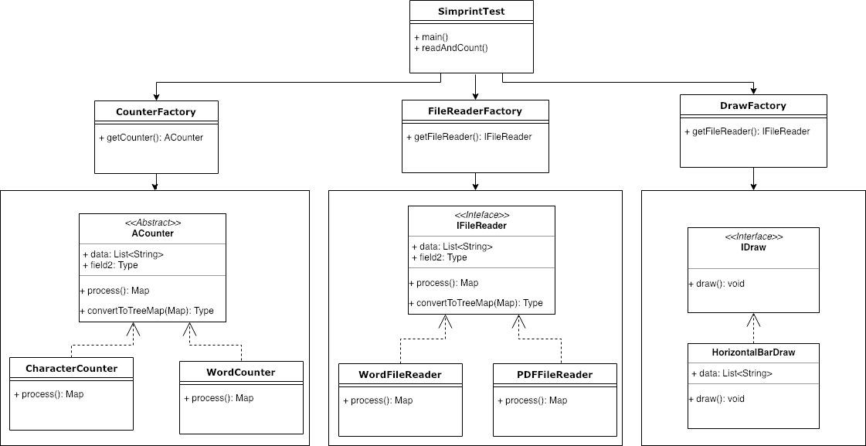

**Interface/Abstract classes:**

**IFileReader:** this interface having method which needed to implemented by its implementation class for reading a given file content. Example, for PDFFileReader, it needed to override the method readAndListData so that it should open a PDF file and read it content and convert it to list of string.

**ACounter:** This interface is mainly focusing on how to process the list of data. It can count the character/words as per its implementation class. Currently I have two class which extends this class, CharacterCounter to count the character and WordCounter to count the words.

**IDraw:** This interface is used to show the data on console. As of now I Have implemented only once class to draw horizontal bar style data.

**Technologies:**

Java has been used to implement this program.

**Limitations:**

1. This is a simple java console application.
2. Loggers not implemented
3. Only PDF and Word document read has been implemented.
4. Only Character count is implemented, Word count is not implement, but placeholder class has been added.
5. Junit testing done only on positive scenario, negative scenario not covered much.
6. Exception handling not implemented properly.